

# Annual Sustainability Report

# 2023-2024

## Introduction

Sustainability is at the core of Exeter College’s strategic plan, as one of Exeter’s four inter-linked values besides excellence, diversity and community. Thus, Exeter College has committed to playing its part in reducing the harmful effects of climate change and biodiversity loss. In 2019 the college set up a Sustainability Working Group to consider policies and initiatives that could make the College’s operations more sustainable. This Working Group has since been made a College committee, formally incorporating it into the College’s structure of governance. In recognition of the importance of this work, Exeter decided to employ a Sustainability Coordinator jointly with Lincoln and Corpus Christi Colleges in 2022. In October 2023, Exeter’s Sustainability Committee developed Smart sustainability targets for the academic year 2023-2024.

This second Annual Sustainability Report outlines the progress against those targets. Each target is coded according to whether it is on track or has been achieved (green), whether further work is required on this target (orange) or whether it has not been achieved (red). Overall, most targets have been achieved. However, further long-term work is required to develop a more detailed estimate of scope 3 emissions and reduce college waste.



**Not achieved**



**Achieved**



**Further Work Required**

## Energy and water savings



**Over-achieved**



**Over-achieved**

Reducing gas use:

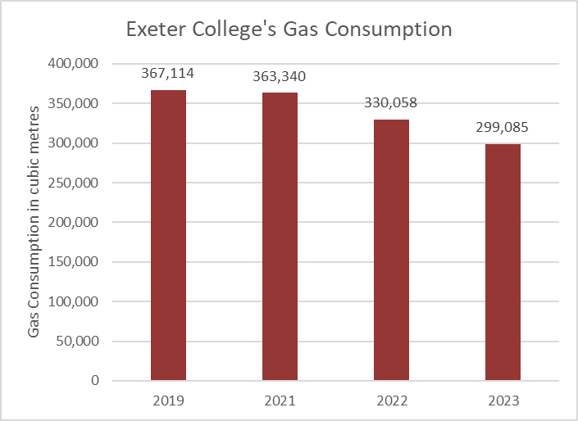

Exeter College has reduced its gas consumption by 18.53% since 2019, with year-on-year reductions above 9% in both 2022 and 2023. As visible in the graph above the College’s gas consumption was 367,114 m3 in 2019. In 2021 this slightly fell to 363,688m3 and in 2022 gas use was reduced substantially to 335,055m3. In 2023 College gas use fell under the 300,000m3 mark.

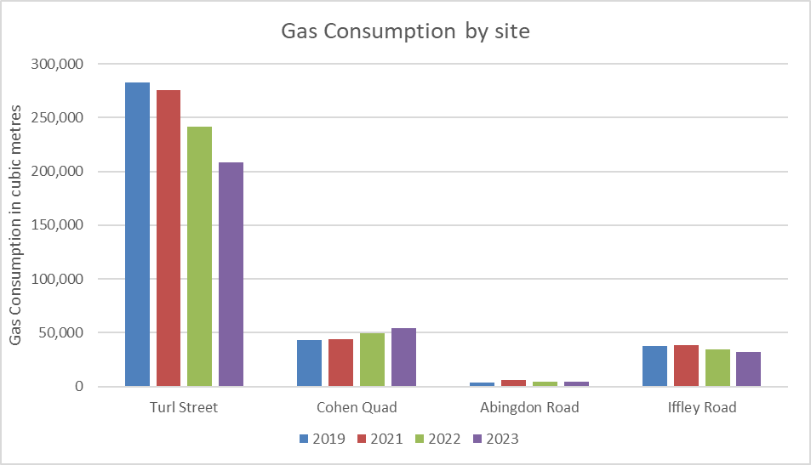

The reduction in gas use was driven mostly by improvements in our heating system in Turl Street from October 2022 onwards. In early 2023, the College installed smart thermostatic radiator valves in Staircases 12-14, which have resulted in further savings in 2023. While part of the increased consumption at Cohen Quad reflects the return to in-person conferences during the summer of 2022, the continued increase is due to a malfunction in the solar array used to pre-heat the hot water supply.  The location of this piece of equipment is such that makes repairs difficult and we are working with our contractors to resolve this.

### Overall: The gas reduction target of -5% has been overachieved. Reducing electricity use



**Over-achieved**

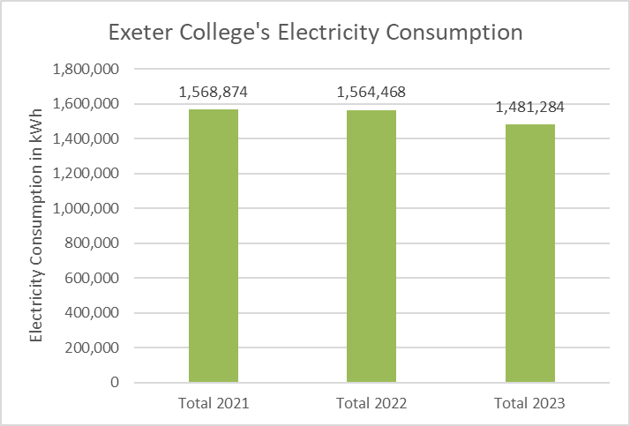

Exeter College has reduced electricity consumption over the past years, with a year-on-year drop by 5.32% in 2023. As the graph above shows, electricity consumption was 1,564,468 kWh in 2022 and dropped down to 1,481,284 in 2023.

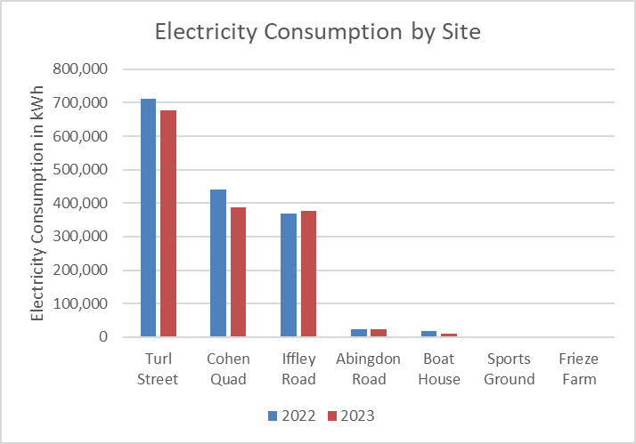

The reduction in electricity use was driven mostly by improvements in our heating system in Turl Street and Cohen Quad, but the Boat House has also seen substantial savings.

### Overall: Our target of not increasing our electricity consumption has been overachieved.

**Reducing water use**



**Achieved**

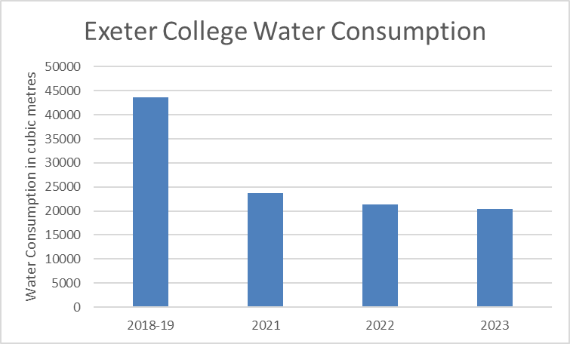

Exeter College has reduced its water consumption on its metered sites over the past years, with a year-on-year drop by 4.76% in 2023. As the graph above shows, water consumption was 20,351 cubic metres in 2022 and dropped down to 20,335 in 2023.

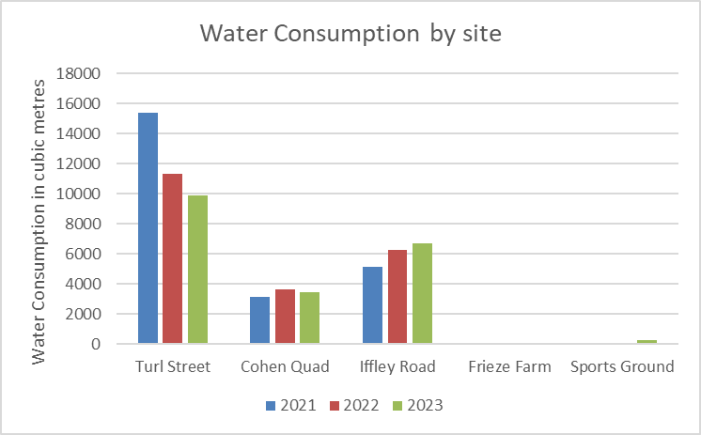

Again, this reduction stemmed mostly from Turl Street, where we have installed water saving devices in bathrooms.

### Overall: Our target of not increasing our water consumption has been achieved.

## Emissions reductions



**On track**

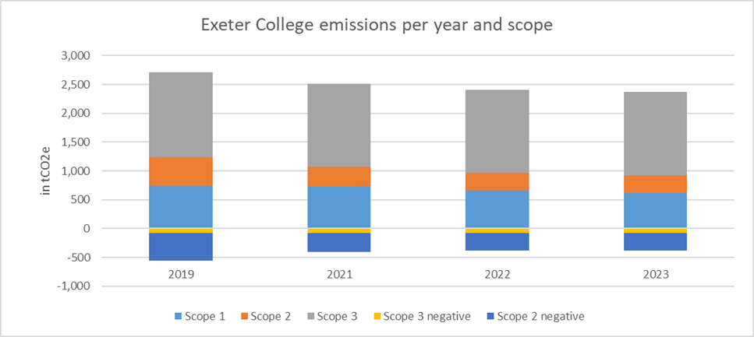

The graph above shows our currently estimated emissions since 2019 by scope (please note that figures for 2020 are not presented as that year was anomalous because of restrictions at the height of the Covid-19 pandemic). Our Scope 1 direct emissions were 611 tonnes Carbon Dioxide equivalent (tCO2e) in 2023, having fallen from 746 tCO2e in 2019. Our Scope 2 indirect emissions fell from 489 tCO2e in 2019 to 307 tCO2e in 2023. These Scope 2 emissions were offset by our procurement of renewable electricity, as made visible through the Scope 2 negative emissions above. Our covered Scope 3 emissions fell from 1472 tCO2e to 1453 tCO2e over this time period. [For more information about what we mean by Scope 1, 2 and 3 emissions click here](https://www.carbontrust.com/our-work-and-impact/guides-reports-and-tools/briefing-what-are-scope-3-emissions).

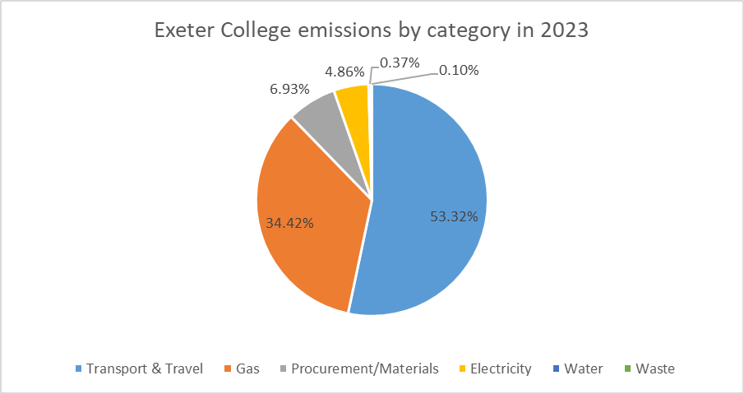

While our Scope 1 and 2 emissions and our Scope 3 emissions for utilities and waste are complete, the figures for procurement and travel are initial estimates. We are working on including more of our Scope 3 emissions as better data become available. The graph above shows the currently estimated makeup of Exeter College emissions by category of activity across all scopes. We expect procurement to be a larger part of our emissions and have not accounted for our endowment in these figures as yet. Unless otherwise stated, the conversion factors for emissions are based on the government’s official figures for the given year ([2019](https://www.gov.uk/government/publications/greenhouse-gas-reporting-conversion-factors-2019), [2021](https://www.gov.uk/government/publications/greenhouse-gas-reporting-conversion-factors-2021), [2022](https://www.gov.uk/government/publications/greenhouse-gas-reporting-conversion-factors-2022), [2023](https://www.gov.uk/government/publications/greenhouse-gas-reporting-conversion-factors-2023)).

### Scope 1: Direct emissions



**Achieved**

Exeter College’s scope 1 emissions from gas fell from 745 tCO2e in 2019 to 734 tCO2e in 2021, 665 tCO2e in 2022 and 610 tCO2e in 2023. In addition, our gas use caused upstream Scope 3 emissions of 101 tCO2e in 2023, together accounting for over 34% of our estimated emissions in the last calendar year.

In addition, the College owns a 2.4 litre diesel van which we have estimated produces annual emissions of 1 tonne of CO2e based on between 1,469 and 1,756 miles driven per year.

Exeter also owns and responsibly manages approximately 12 hectares of woodland and six hectares of grassland including a site of special scientific interest (SSSI). Together these absorbed approximately 74 tonnes of CO2e each year (University of Oxford Carbon Accounting Tool 2020).



**Achieved**

### Scope 2: Electricity

Scope 2 emissions remain zero due to our long-standing policy of procuring renewable electricity. By procuring electricity generated from renewable sources the College avoided the production of 489 tCO2e in 2019, 333 tCO2e in 2021, 303 tCO2e in 2022 and 307 tCO2e in 2023. Nonetheless, our electricity use in 2023 caused upstream emissions amounting to 100 tCO2e, which is around 5% of our total emissions. This has fallen from 116 tCO2e in 2019, 124 tCO2e in 2021 and 107 tCO2e in 2022.



**Further Work Required**

### Scope 3: Estimating our upstream and downstream emissions

Scope 3 upstream emissions for energy have been fully calculated and provided above. For water and waste they have been calculated based on the available water and waste data (excluding un-metered water and non-weighed waste). The estimates for procurement, transport and travel emissions are initial approximations, which will be fine-tuned in future years.

*Water*

In 2023 water supply and treatment led to emissions of 8 tCO2e. This has fallen from 9 tCO2e in 2022, 10 tCO2e in 2021 and 45 tCO2e in financial year 2018-2019.

*Waste*

Emissions from non-hazardous and non-junk waste were 2 tCO2e per year for the last two years we have data for.

*Procurement*

Our waste figures highlight the amounts of materials produced for us, with at least 37 tCO2e upstream emissions related to the production of items that ended up in our glass, paper and dry mixed recycling waste streams in 2023. Our IT procurement was also responsible for around 6 tCO2e in 2023, based on conversion figures from a recent study (Lövehagen et al., 2023).

The food-based carbon footprint is calculated by broad approximation. The calculation uses the College’s 2021 catering operations and is based on the equivalent of circa 19,200 day consumers at 5.2Kg/CO2e per day (source: "Food in a warming world: the changing foods on the British Plate", WWF, 2018; which is broadly consistent with data from “Dietary greenhouse gas emissions of meat-eaters, fish-eaters, vegetarians and vegans in the UK” by Scarborough P. et al., Nuffield Department of Population Health, Oxford, 2014). This equates to 100 tonnes of CO2e from food in 2021.

These procurement emissions are only an initial estimate with large gaps in data remaining. Thus, the proportion of our total emissions will be higher than the 7% currently allocated to procurement.

*Transport and travel*

An initial estimate of our transport and travel emissions lies at 1,100 tCO2e in 2023. While there is a lot of uncertainty associated with this figure, the scale of these emissions is important to note. Together with emissions from food deliveries (based on data from Foodquad) and our college van, which are both estimated at 1 tCO2e per year, emissions from student and business travel are higher than all other currently calculated and estimated emissions combined. Emissions from flights for College business amounted to 53 tCO2e in 2023.

We have assumed that UK students travelled to Oxford by car, with a family member or friend dropping them in Oxford and then making the return trip home. For our calculations we included 100% of emissions for postgraduate students, rather than dividing their emissions equally between their University department and the College. For the purposes of estimating the CO2e emissions we assumed that the average return journey was 400 miles, equivalent to driving from Lancaster to Oxford and back. This equates to 174 tCO2e from our UK students travelling to and from Oxford (University of Oxford Carbon Accounting Tool 2020).

We assumed our international students on undergraduate and taught postgraduate courses made two return flights from their home country and that postgraduate students taking research degrees made one return flight from their country of origin. For our calculations we included 100% of emissions for postgraduate students, rather than dividing their emissions equally between their University department and the College. For the purposes of estimating emissions we assumed each student flew from the capital city of their country of residence to London and vice versa for return trips. This equates to 872 tCO2e from our international students travelling to and from the UK (University of Oxford Carbon Accounting Tool 2020).

## Long-term building decarbonisation plans



**On track**

The College commissioned a feasibility study to explore decarbonisation options at our Turl Street, Exeter House, and Stapledon House sites in 2021. The study was completed in August 2021 and highlighted various options for those sites. In early 2022 the College commenced the next stage and is now assessing the detailed upgrades needed to support our long-term transition to a decarbonised mechanical and electrical infrastructure on the Turl Street site. The first projects including solar panels, improved insulation and ground source heat pumps have received in principle support at pre-application stage. There is now more work required to raise funds, develop detailed designs and gain certainty in terms of electrical grid capacity.

## Waste reduction



**Further work required**

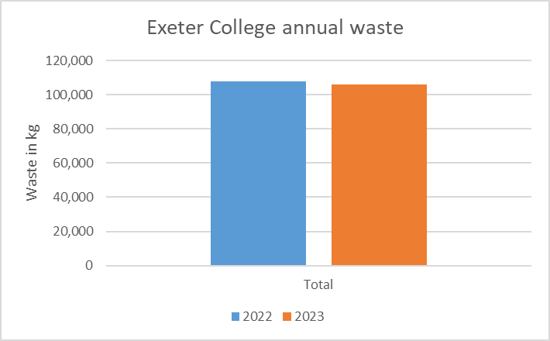

In 2023, SELECT collected 106 tonnes of waste from Exeter College, which was marginally lower than the 108 tonnes collected in 2022, although it included more waste streams.

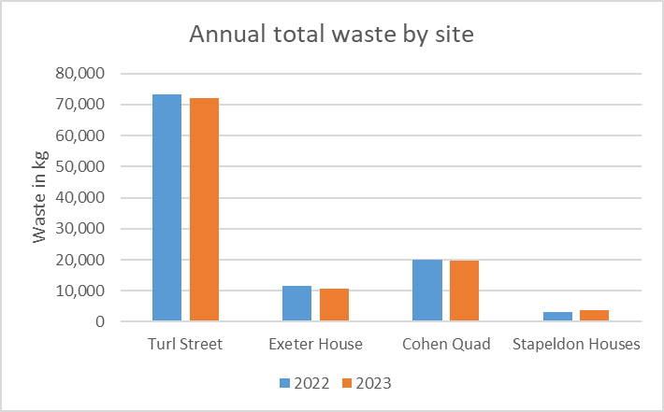

Since the switch to SELECT Environmental Services, Exeter College’s non-hazardous, non-junk waste is weighed at collection, providing a monthly picture of waste collection across Cohen Quad, Exeter House, Stapledon Houses and the main site on Turl Street. Abingdon Road and Frieze Farm are not included in this data.

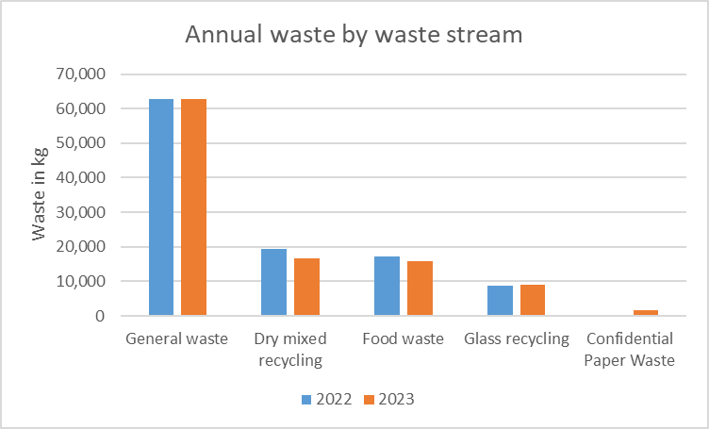

More than 40% of the College’s waste is directed towards more sustainable categories: in 2023, more than 25% of waste was recycled and over 15% was sent to anaerobic digestion. Nonetheless, there is room for improvement, which the newly formed Waste Team is working on.

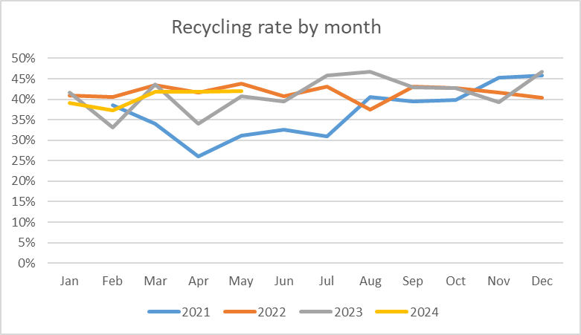

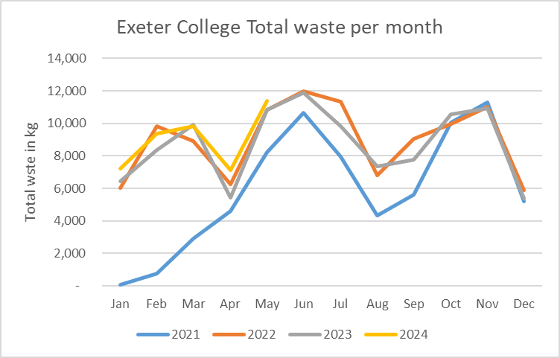

## Acquiring an electric van to replace the existing diesel van



**Further work required**

College is in the process of acquiring an electric van and are looking to replace the diesel van with an electric van in the coming year.

## Building community impact through the Green Impact scheme



**Achieved**

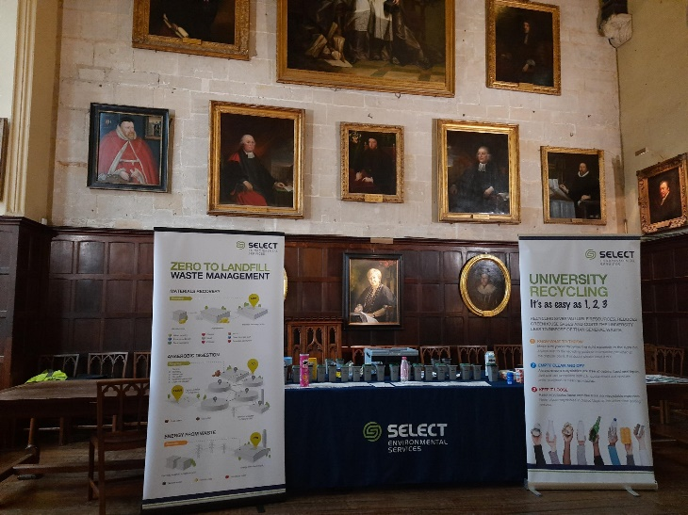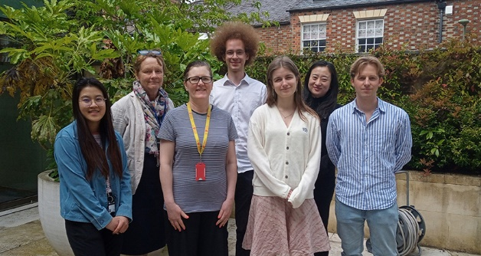Exeter’s Green Impact Team met regularly throughout the academic year, including with similar teams at neighbouring colleges, to identify and implement ways of making Exeter more sustainable. Thanks to a dedicated team, Exeter College retained its Gold Award. After achieving Gold for two years in a row, we can now put Beyond Gold in our vision for next year. See some images of some of the initiatives below

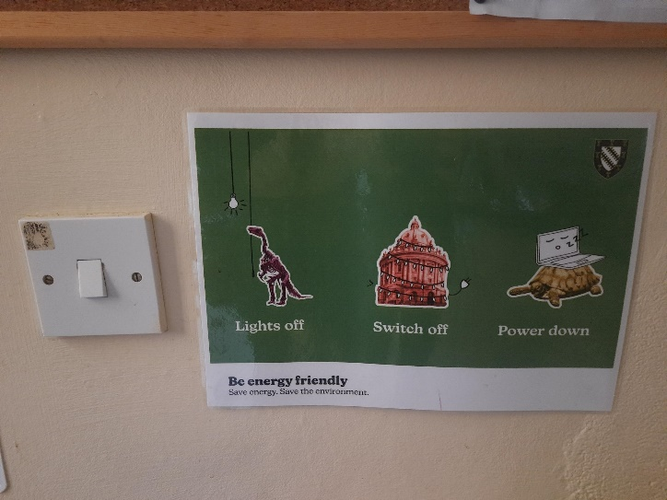

## Biodiversity: understanding impacts and acting on opportunities



**Further work required**

As per the College policy, the sports ground has gained a new wild grasses and wild flower area, part of which was planted by our Green Impact Team. Linked to the redevelopment of the sports ground, more biodiversity projects will be happening here.

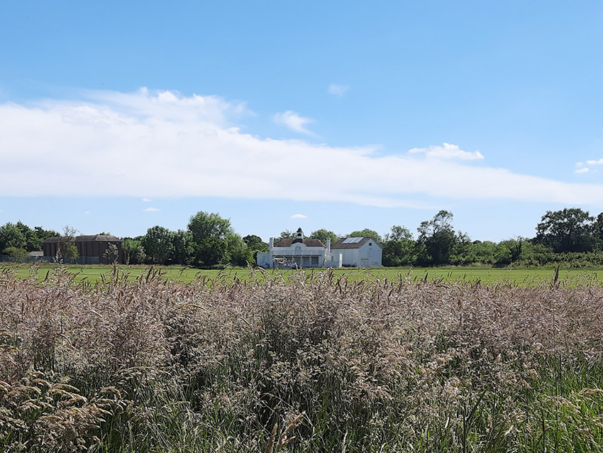

The College now has biodiversity audit reports for all its wider estate. Plans for improvements now need to be made.