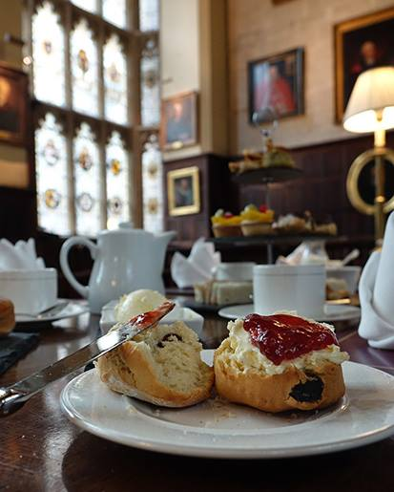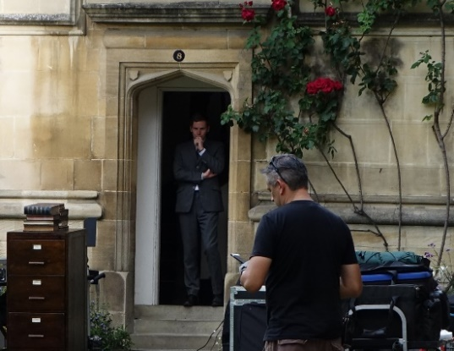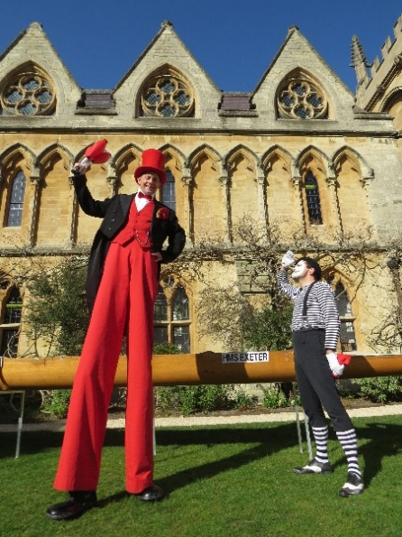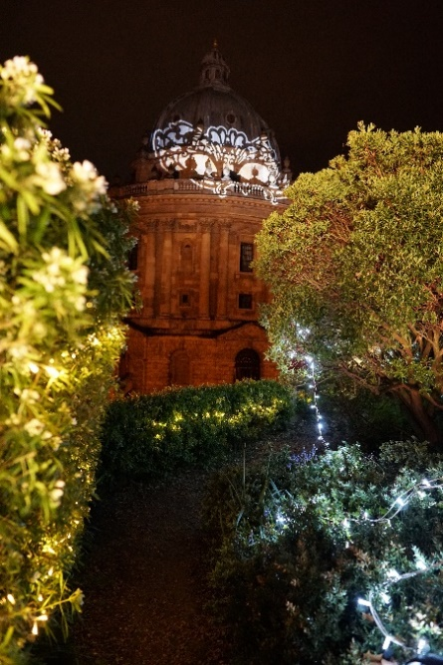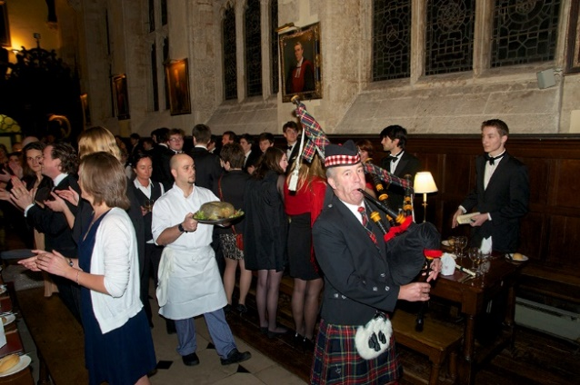

EVENT BOOKING FORM



Event Booking Form

Title of Event Click or tap enter text.

Date of Event Click or tap to enter a date.

Organisation Click or tap here to enter text.

Contact (name): Click or tap here to enter text. Telephone: Click or tap here to enter text.

Address: Click or tap here to enter text.

Email: Click or tap here to enter text.

**Event Details Is your event VAT exempt?** Yes  No

Number of Guests: Click or tap here to enter text.

**Reception** **Meal**

Venue: Click or tap here to enter text. Venue: Click or tap here to enter text.

Time: Click or tap here to enter text. Time: Click or tap here to enter text.

**How did you hear about Exeter College? (X one option)**

Conference Oxford  Oxfordshire Venues Booklet  Word of Mouth

Repeat Business  Other

**If your event involves music (live/amplified/DJ or any other kind), please give details:**

Click or tap here to enter text.

**Any Other Details**

Click or tap here to enter text.

Please complete this form to advise us of your requirements, returning it to:

The Steward

Exeter College

Turl Street

Oxford

OX1 3DP

01865 279630

[philip.munday@exeter.ox.ac.uk](mailto:philip.munday@exeter.ox.ac.uk)