

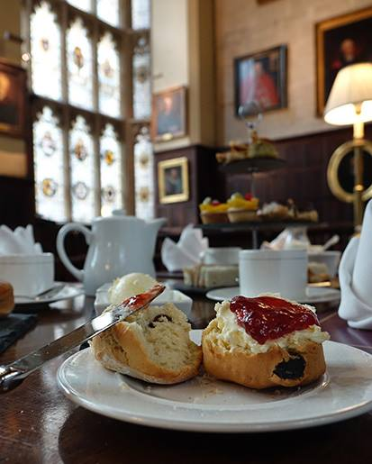
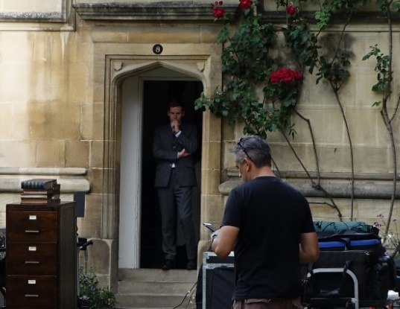
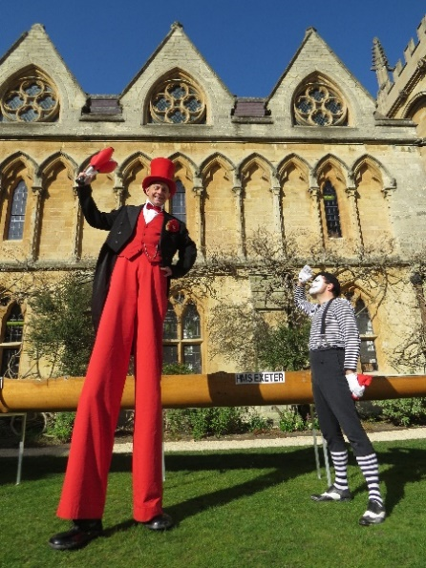
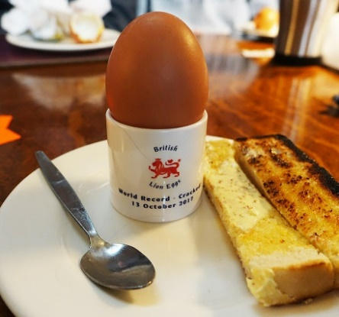
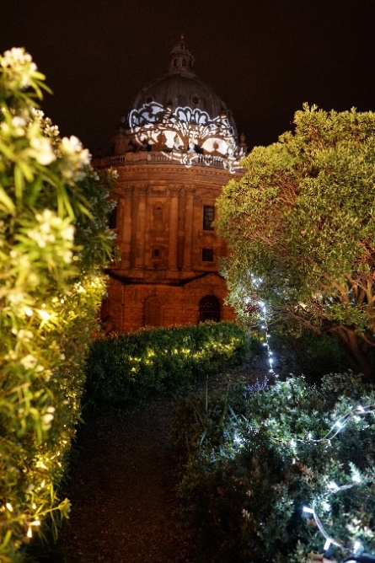

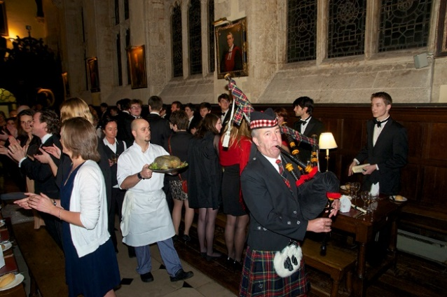
EVENT BOOKING FORM



Event Booking Form

Title of Event Click or tap enter text.

Date of Event Click or tap to enter a date.

Organisation Click or tap here to enter text.

Contact (name): Click or tap here to enter text. Telephone: Click or tap here to enter text.

Address: Click or tap here to enter text.

Email: Click or tap here to enter text.

Event Details Is your event VAT exempt? Yes ☐ No ☐

Number of Guests: Click or tap here to enter text.

Reception Meal
Venue: Click or tap here to enter text. Venue: Click or tap here to enter text.

Time: Click or tap here to enter text. Time: Click or tap here to enter text.

How did you hear about Exeter College? (X one option)

Conference Oxford ☐ Oxfordshire Venues Booklet ☐ Word of Mouth ☐

Repeat Business ☐ Other ☐

If your event involves music (live/amplified/DJ or any other kind), please give details:
Click or tap here to enter text.

Any Other Details
Click or tap here to enter text.

Please complete this form to advise us of your requirements, returning it to:

The Steward
Exeter College
Turl Street
Oxford
OX1 3DP
01865 279630
philip.munday@exeter.ox.ac.uk

